**Summary Biography   
Alejandro Grosso Laguna  
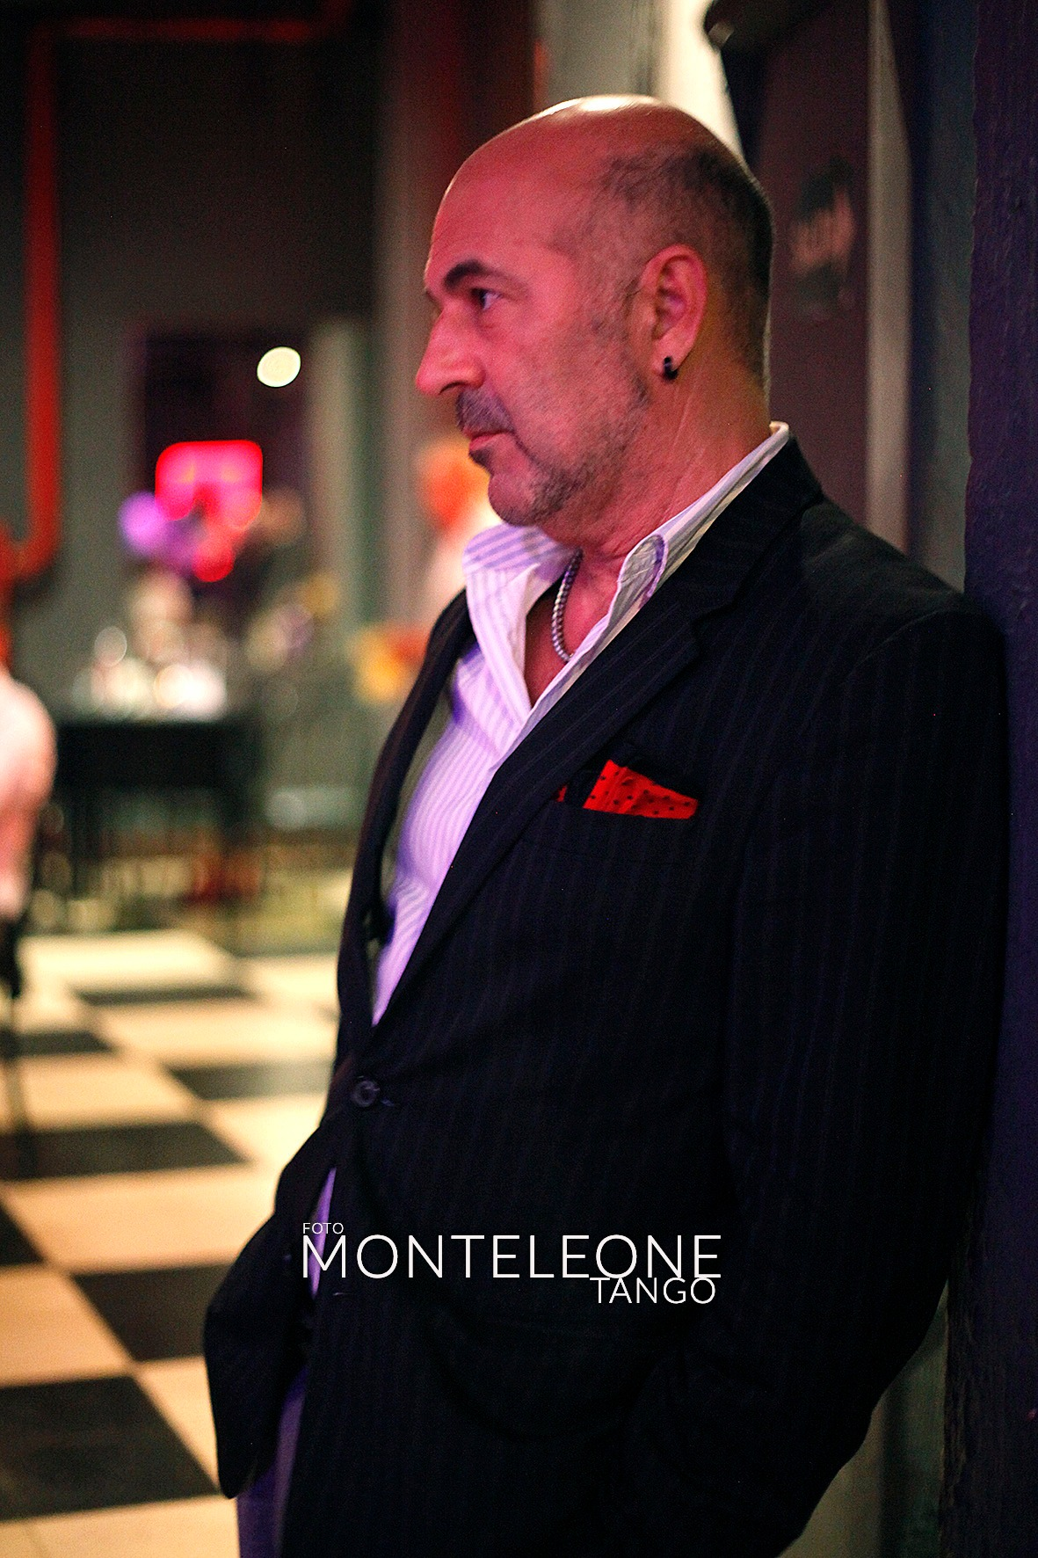 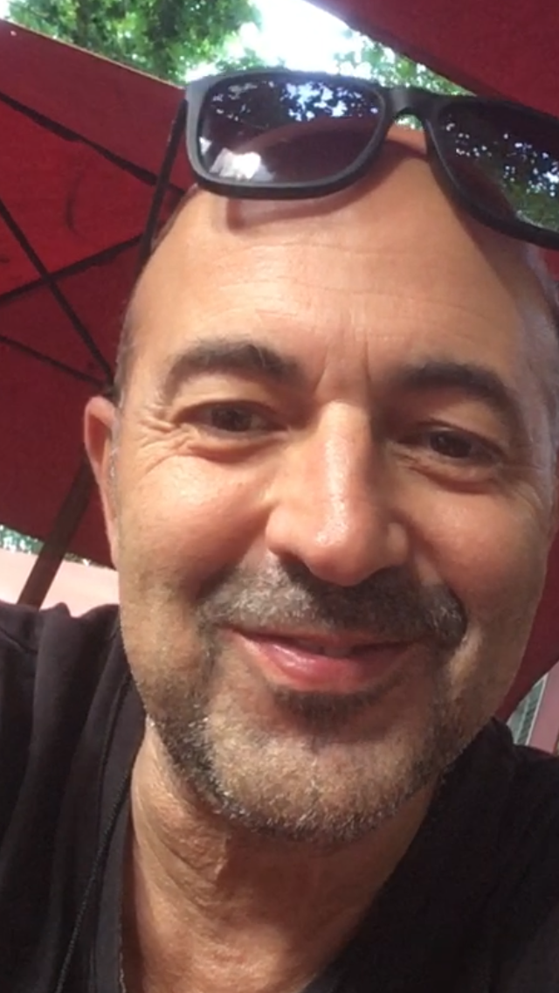**

línea horizontal

Alejandro is PhD Researcher in Performing Arts —Dance Movement and Music, a Professional Tango Dancer and Teacher, and a Musician specialized in Contemporary and Modern Dance Technique, born in Buenos Aires City, Argentina.

**EDUCATION**  
He completed the DOCTOR OF PHILOSOPHY in Artistic Studies by the University of Évora. Awarded Grant by the Foundation for Science and Technology of Portugal (FCT.IP). His doctoral thesis addresses communication problems between dancers and between dancers and musicians in dance technique classes.

He holds a DEGREE IN MUSIC EDUCATION from the University of Évora (2007) and Musical Education and Classical Guitar (1990) at the Higher Conservatory of Music “Manuel de Falla” of Buenos Aires. He also studied during 3 years at the Faculty of Arts of National University of La Plata.

From 2011 to the present he has had advanced training in GYROTONIC Expanded System, Movement Technique and main notions of classical ballet technique with Barbora Hruskova (principal dancer of the National Ballet Company of Portugal and current ballet master of this company).

PROFESSIONAL TANGO DANCER. Since the late 90’s, his training and references in tango dance have been relevant Argentinian dancers namely Aurora Lubitz, Nélida Miglione, Jorge Ramirez, Carlos Borquez, Inés Borquez, Sergio Natário, Alejandra Arrué, Ana Maria Schapira.

From 2015 to date Alejandro has been academically investigating the roots and foundations of ‘TANGO SALÓN / VILLA URQUIZA'. In this sense, he has maintained close ties with the iconic choreographer and dancer Milena Plebs and studied with the dancer Graciela González, considered a teacher of teachers.

Currently and since 2017 Alejandro continues to study ‘TANGO SALÓN’ with the milongueros Alfredo Alonso and Silvia Mucci ('Los Alonso'), a couple considered the main reference of the traditional style still active.

In 2022 he attended some master classes in Buenos Aires with Gustavo Naveira and Giselle Anne, and seminaries about “popular tango phrases” with Olga Besio.

His experience and knowledge in tango dance comes from his practice immersion in referents traditional Milongas of Buenos Aires City since the late 90s. (El Beso, Salón Canning, Lo de Celia, among many others.)

**RESEARCH / PRODUCTION**

In his professional career stands out 7 years of POSTDOCTORAL RESEARCHER, awarded Grant by the FCT.IP. His projects addresses “Aspects of communication in multimodal expressive performance: Crossing propositional and non-propositional content*s”* and “How to think of art from the body? Phenomenological Investigation on the Construction and Transmission of Non-Propositional Knowledge.”

Alejandro has PUBLISHED 30 works in SCIENTIFIC JOURNALS OF ART, among them in *Research Dance in Education*, a Taylor and Francis Editorial best-ranked (Q1) journal for investigation in dance.

**AFFILIATION / SCIENCE**

Alejandro is currently member of the R&D Ethnomusicology Institute - Music and Dance Research Centre (INET-MD) - University of Aveiro (UA) and R&D Laboratory for the Study of Musical Experience (LEEM) of the Faculty of Arts, National University of La Plata (UNLP).

During the last years Alejandro was part of two research competitive projects. The PICT-2008-0927, "Intersections between musical experience and early childhood in the framework of corporate cognition and the PICT-2013-0368 "Communicative Musicality In the Time Arts and Early Childhood", both funded by the National Agency for the Promotion of Science and Technology, Argentina and developed at LEEM.

**GRADUATE TEACHING**

Since 2014, he has taught in Doctorate, Masters and Degree seminars at the Faculty of Human Kinetics of the University of Lisbon; no Laboratory for the Study of Musical Experience (UNLP), Argentina; and Dance Faculty of University Autonomous of Chiapas, Mexico.

Alejandro has more than 15 years experience as DANCE MUSICIAN specialized in modern and contemporary dance (Assistant Professor of the Lisbon Higher School of Dance) highlighting his collaboration with the dancer Antonio Carallo (Tanztheater Wuppertal Pina Bausch) for five years. ​

**TANGO / PORTUGAL**

Alejandro was the first teacher to give regular Tango classes in Lisbon (Mai 1997, Athenéu Comercial of Lisbon). In June 1997 he began to organize ‘the práctica’ in Lisbon at ABS Privado. A year later (September 1998) he created, the first milonga in Portugal (Rua de Santo Amaro, 8 - Campo de Ourique) together with the portuguese dancer Solange Galvão.

During 1999 they founded three other milongas. The first in the bairro de Madragoa in the Vendedores de Jornais Futebol Club (early 1999), the second in the Club Estefânia (late 1999), and the third in the Santos neighborhood, the iconic MILONGA d'A BARRACA (July1999). These projects was dedicated to disseminating the cultural identity of the milonga 'porteña' and tango social dance.

The Milonga d'A Barraca takes place in the mythical Bar of the A Barraca Theater - Cinearte and is directed by Alejandro weekly since 1999. It is considered the oldest traditional regular milonga in Europe – almost 24 years old - organized by an argentine dancer, in the same space every Sundays.

In April 2020 Alejandro created a TANGO LABORATORY that aims to develop a methodology to study and transmit non-propositional knowledge that shapes the roots and foundations of traditional Tango Dance.

**TANGO and FADO**

The originality of Alejandro’s Milonga d'A Barraca is also to promote the encounter between TANGO and FADO. In this meeting "inside the milonga with the same light as a Fado house" a magical moment has been taking place for two decades reserved for "dancing the fado" through a free interpretation of the tango figures.

Around 80 fadistas have performed at the Milonga d'A Barraca. Among the most prominent we can name Celeste Rodrigues, Katia Guerreiro, Helder Moutinho, António Chainho, Fernando Alvim, Luís Guerreiro, Carlos Manuel Proença, Pedro de Castro, Maria Amélia Proença.

Since mid-2022 Alejandro has been a dance partner with Camila Delphim, a talented Brazilian profissional dancer born in the state of Rio de Janeiro who was a finalist in the World Tango Dance Tournament (Buenos Aires) in the stage category. Camila thus joins the project “Collaborative Artistic Reconfiguration of the Tango Dance towards Fado.” Alejandro and Camila maintain a close bond with the houses of Fado, their rituals, their musicians and their fadistas. In their short career together they have performed in several Fado houses such as Fado ao Carmo, Tasca da Bela, Mesa de Frades, A Nini

**Full CV:** https://www.cienciavitae.pt/191E-174E-5492

**Some Publications in Scientific journals**

(2022) Grosso Laguna, A and Favio Shifres. **Visual and Sound Gesture in Dance Communication**. *Research in Dance Education*. Routledge. Taylor & Francis.

(2021) Grosso Laguna. **Graciela González: Bodily experience and generational change in traditional tango**. *European Review Of Artistic Studies.*

(2020) Grosso Laguna, A. **Biomechanical Analysis and Metric Interpretation of ‘Walking’ in Tango Dance**. *European Review of Artistic Studies.*

(2020) Grosso Laguna, A and Favio Shifres. **Understanding Movement from Dance and Music**. *European Review of Artistic Studies.*

# (2019). Grosso Laguna. Cuando el cuerpo es música al bailar. Entrevista a Claudio Villagra. *Epistemus.*

# (2018) Grosso Laguna, A. Milena Plebs. Tango y Pensamiento Critico. Conexiones con la vivencia de los procesos de enseñanza y aprendizaje de la música. *Epistemus.*